Individual Pathways
Activity 10.2 Answers
Investigating energy
- Read the following paragraph and highlight the key terms to help you answer the questions that follow.
Answers will vary. Example is given.
All energy forms can be separated into one of two categories of energy: potential energy (stored energy) and kinetic energy (energy that moving objects have). As a result, electrical energy (which is due to moving charges), light energy (which is due to the movement of electromagnetic waves), sound energy (which is due to motion of compressional waves through a medium) and heat energy (which is due to the vibration and movement of particles) are actually all forms of kinetic energy. What we generally call kinetic energy could be described more precisely as macroscopic motion energy. On the other hand, gravitational, elastic, chemical and nuclear energy are all forms of potential energy.
- Summarise the information above into the following table. Provide an example of each of the energy types listed in the table.
Answers will vary. Examples are given.
Potential energy |  | Kinetic energy
Name of energy | Example | Name of energy | Example
Gravitational | Parachutist | Macroscopic motion energy | Person walking
Elastic | Wound watch spring | Electrical | Battery
Chemical | Sugar | Light | Light globe

- Describe the energy transformation illustrated.
Potential energy to kinetic energy
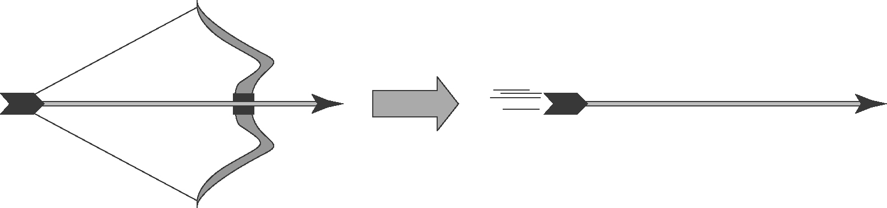
- Testing conduction
The heat conduction properties of a new material were tested. One end of a 100 cm long rod of the material was heated, and the temperature of the rod at the other end was recorded every minute. The data is tabulated below.
- Plot a line graph of the data and draw the line of best fit. (Start your graph at 20 °C.)
Time (min) | Temperature (°C)
0 | 20.0
1 | 25.0
2 | 29.8
3 | 35.2
4 | 40.0
5 | 44.7
6 | 50.3
7 | 54.9
8 | 59.9
Answer:
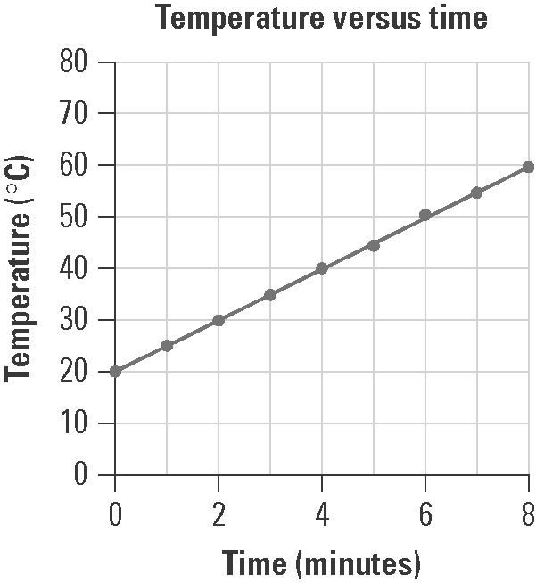
- Use your graph to estimate the temperature of the rod at 3.6 minutes after the start.
38 °C
- Identify the dependent and independent variables in this experiment.
Independent variable: time
Dependent variable: temperature
- Convection
Consider the following illustration showing the movement of air near the ocean shore. Describe how the production of convection currents makes the climate near the coast milder than it is inland.
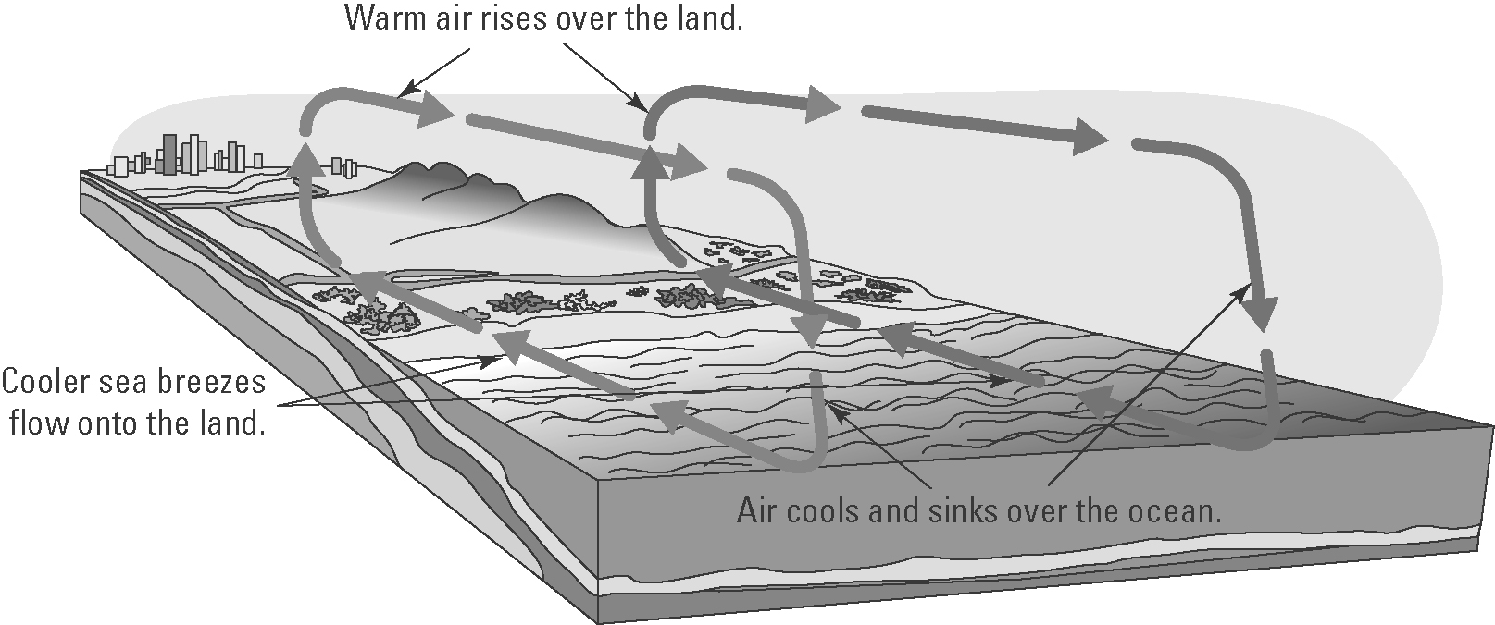
Warm air rises over the heated land and is replaced by cooler sea breezes flowing off the sea. This sets up a convection current in which the warmer air at a higher altitude flows towards the coast, where it sinks as it cools. This means that coastal climates are cooler as the sea breezes are cooler.
- The diagram shows an incandescent light bulb.
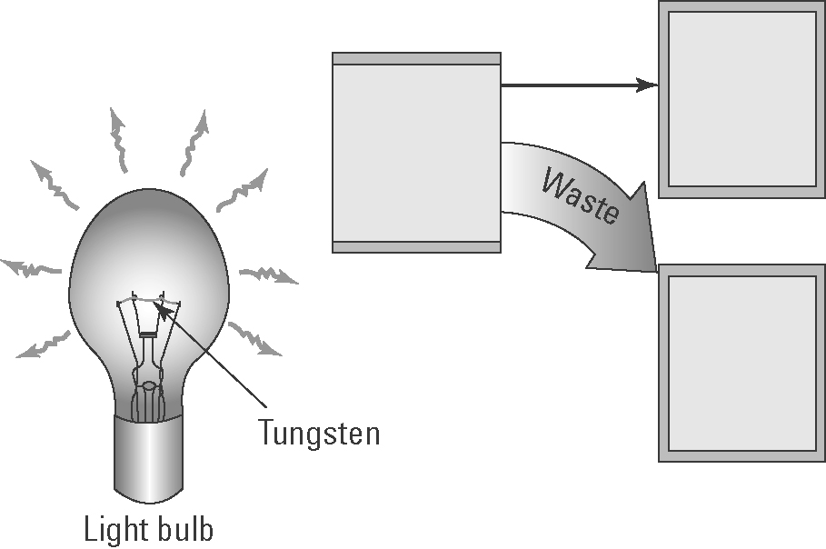
- Explain how an incandescent light bulb generates light.
Incandescent light bulbs contain a filament made of tungsten that is luminous or glowing due to the high temperature of the wire as the current flows through it.
- Insert the following words in the boxes in the diagram:
heat energy, electrical energy, light energy
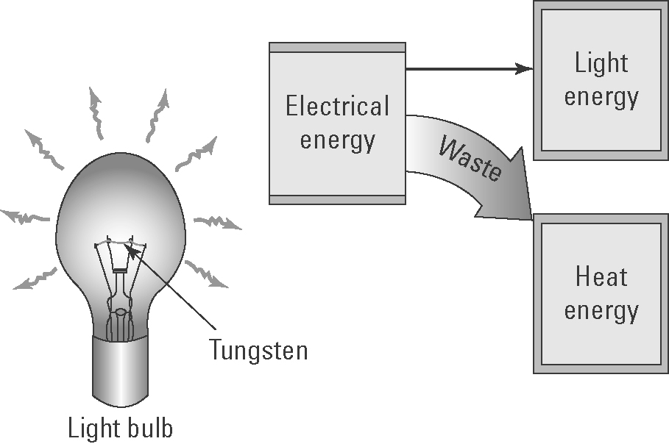
- Explain why incandescent light bulbs are not energy efficient.
They are not energy efficient as most of the energy released is heat rather than light.
- Wavelength and frequency
The following diagram shows two vibrating tuning forks producing sound waves.
A | 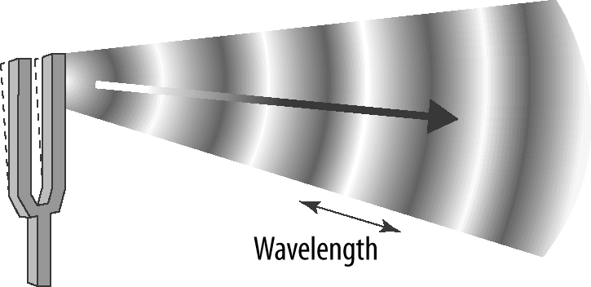 | (a) Identify the features of the wave labelled X and Y.  X: rarefaction  Y: compression
B | 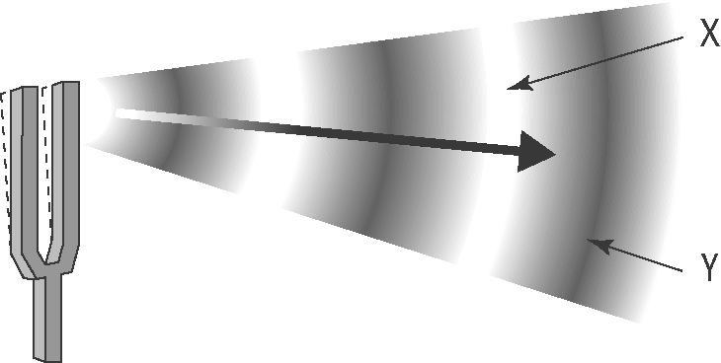 | (b) Which tuning fork produces sound waves with the lower pitch? Explain.  B has the lower pitch (or frequency) as its wavelength is greater.
- Speed of sound in water
The following graph shows how the speed of sound (in m/s) in water varies with temperature (in °C).
- The labels and units on each axis are not shown. Insert these labels and units.
- Give the graph a title.
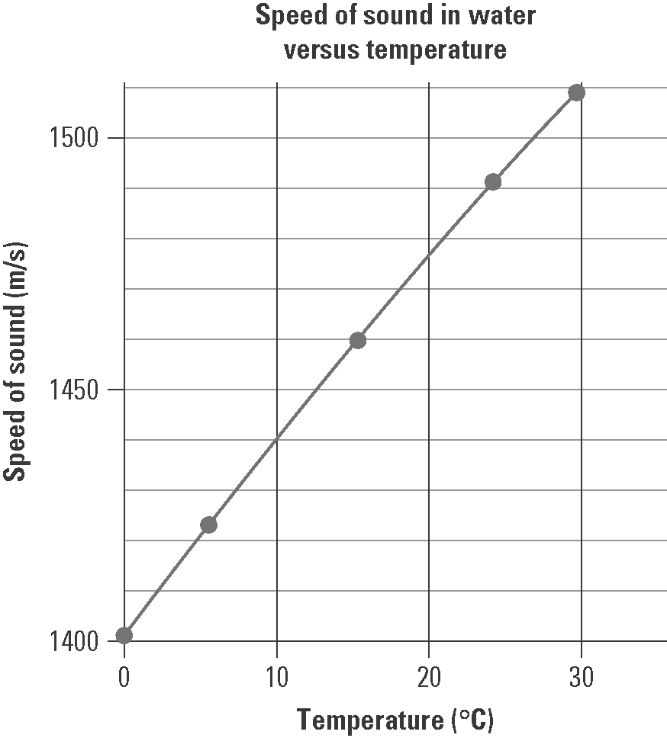
- Use the graph to determine the speed of sound in water at:
(i) 0 °C 1405 m/s
(ii) 10 °C 1440 m/s
(iii) 20 °C 1475 m/s
- In air, the speed of sound at 0 °C is 331 m/s.
(i) How many times faster does sound move in water than air at that temperature? (Hint: Divide one speed by the other.)
, therefore more than four times faster

(ii) Explain why sound moves faster in water than in air.
The sound moves faster in water than air as the particles are much closer together and so collisions occur more frequently and thus the energy is passed on to the next particle more quickly.

